David A. Hairston

# 5-1 Project One Submission

6/4/2023

1. the Austin Animal Center (AAC) Outcomes data set into MongoDB by **importing a CSV file using the appropriate MongoDB import tool**. This file is in the /usr/local/datasets/ directory in Apporto; the filename is “aac_shelter_outcomes.csv.” Use the database name “AAC” and collection name “animals.”

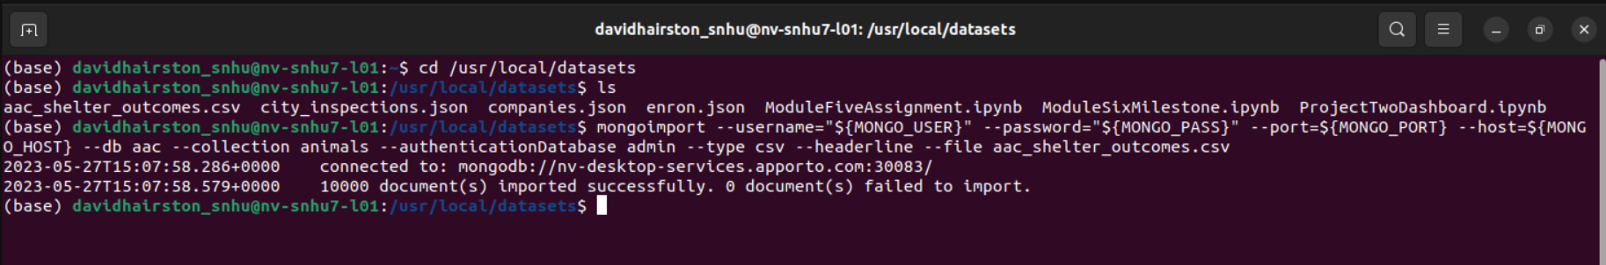



1. Create a user account in the mongo shell to ensure user authentication to the database and collection you created:





1. **Develop** a CRUD class that, when instantiated, provides the following functionality:

* **A *Create* method that inserts a document into a specified MongoDB database and collection**
  + Input -> argument to function should be the key/value lookup pair to use with the MongoDB driver find API call.
  + Return -> “True” if successful insert, else “False”.
* **A *Read* method that queries for document(s) from a specified MongoDB database and specified collection**
  + Input -> arguments to function should be the key/value lookup pair to use with the MongoDB driver find API call.
  + Return -> result in a list if the command is successful, else an empty list.  
    **Important:**Be sure to use **find()** instead of **find_one()** when developing your method. **Hint:** You will have to work with the MongoDB cursor returned by the find() method.
* **An *Update* method that queries for and changes document(s) from a specified MongoDB database and specified collection**
  + Input -> arguments to function should be the key/value lookup pair to use with the MongoDB driver **Find API** call. The last argument to function will be a set of key/value pairs in the data type acceptable to the MongoDB driver update_one() or update_many() API call.
  + Return -> The number of objects modified in the collection.
* **A *Delete* method that queries for and removes document(s) from a specified MongoDB database and specified collection**
  + Input -> arguments to function should be the key/value lookup pair to use with the MongoDB driver find API call.
  + Return -> The number of objects removed from the collection.

